Assignment 3 Austin Frownfelter

# Problem 1

## (A)

An ML estimate of Theta is 0.65

## (B)

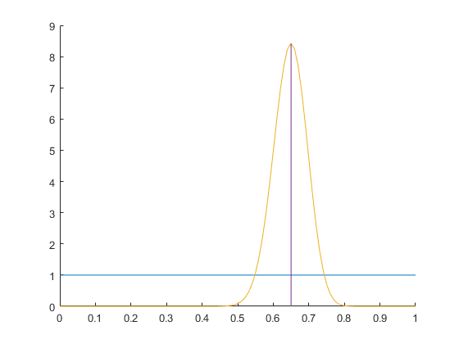

The prior distribution on Theta is blue, and the posterior distribution is in yellow.

## (C)

The above graph shows the MAP estimate for the posterior distribution in purple. That value is 0.65.

## (D)

### C:\Users\frown\AppData\Local\Microsoft\Windows\INetCache\Content.Word\p1part4.png

The prior distribution on Theta is in blue, and the posterior distribution is in yellow.

The map estimate for the posterior is in purple, and the prior in red. The MAP estimate for the posterior is 0.6538.

# Problem 2

## (A)

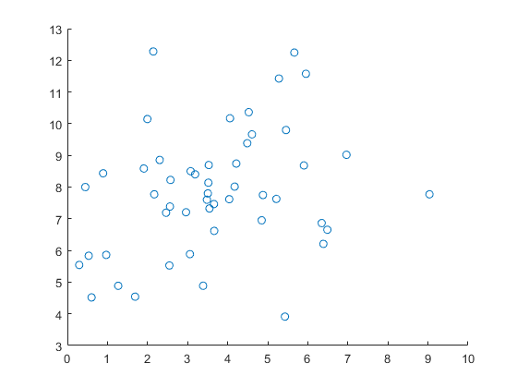

## (B)

Means

|  |  |
| --- | --- |
| 3.6377 | 7.8506 |

Covariances

|  |  |
| --- | --- |
| 3.6414 | 1.0779 |
| 1.0779 | 3.7831 |

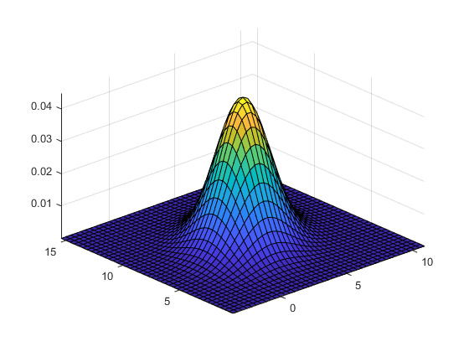

## (C)

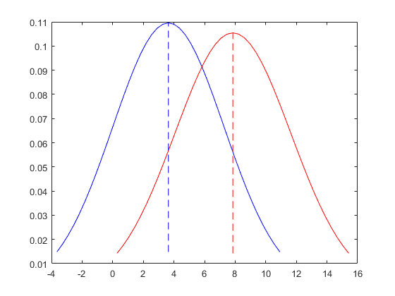

The first measurement is in blue, the second in red. The corresponding means are 3.6377 and 7.8506. The corresponding variances are 3.6414 and 3.7831.

## (D)

I believe the multivariate Gaussian model represents the data better than the separate univariate Gaussian models. It is clearer where there are more “clustered” data points since the multivariate can show it directly. In the case of the univariate models, it is left to inference to decide how the two models are affected by each other.

# Problem 3

## (A)

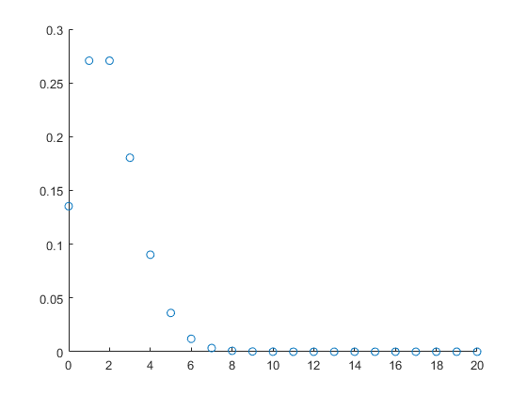

This represents the Poisson distribution with lambda = 2.

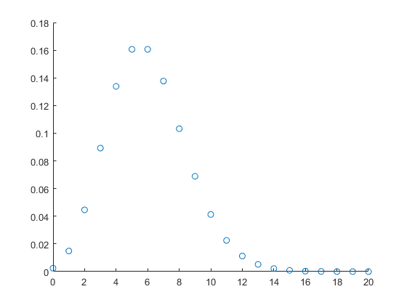

This represents the Poisson distribution with lambda = 6.

## (B)

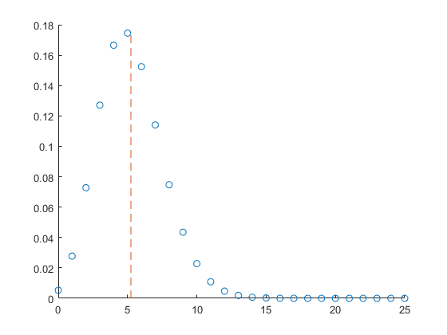

The orange dashed line is the ML estimate for the parameter lambda, which has a value 5.24. The scatter points is the probability function for this calculated lambda.

## (C)

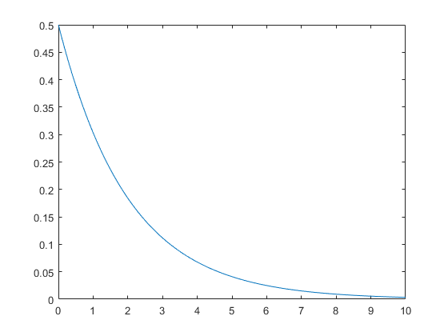

The above graph represents the Gamma distribution defined in the Problem description for a=1, b=2.

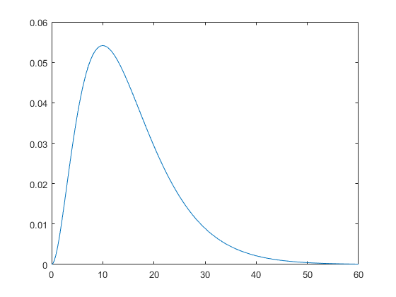

The above graph represents the Gamma distribution defined in the Problem description for a=3, b=5.

## (D)

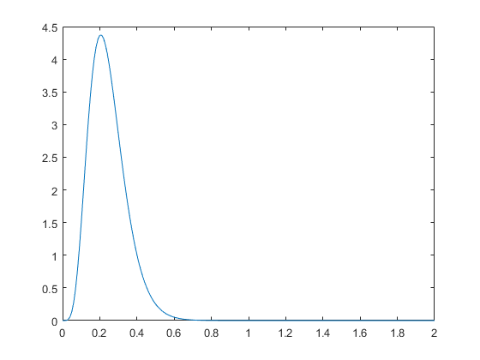

The above graph represents the posterior distribution for prior values of a=1, b=2.

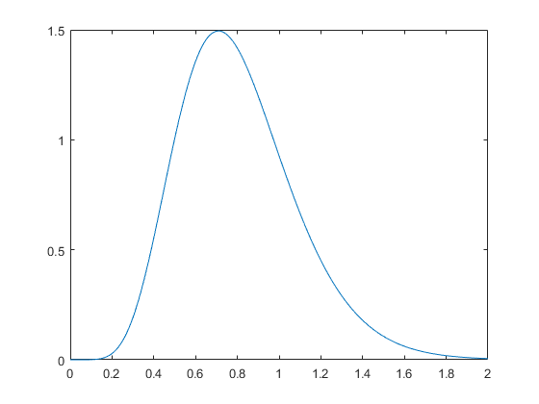

The above graph represents the posterior distribution for prior values of a=3, b=5.